# Task2

#include<iostream>

using namespace std;

class UniverstyPersoanlData {

string name;

int CNIC;

string Adress;

char BloodGroup;

string Department;

public:

UniverstyPersoanlData(string name, int CNIC, string Adress, char BloodGroup, string Department)

{

this->name = name;

this->CNIC = CNIC;

this->Adress = Adress;

this->BloodGroup = BloodGroup;

this->Department = Department;

}

void Dispaly()

{

cout << "The name of the perosn ::";

cout << this->name;

cout << endl;

cout << "The CNIC of the Person ::";

cout << this->CNIC;

cout << endl;

cout << "The Adress of the person ::";

cout << this->Adress;

cout << endl;

cout << "The Blood Group of the person ::";

cout << this->BloodGroup;

cout << endl;

}

};

class Teacher :public UniverstyPersoanlData {

int EmployeeID;

int Salry;

public:

Teacher(int EmployeeID, int Salry, string name, int CNIC, string Adress, char BloodGroup, string Department) :UniverstyPersoanlData(name, CNIC, Adress, BloodGroup, Department)

{

this->EmployeeID = EmployeeID;

this->Salry = Salry;

}

void Display()

{

cout << "The Employee id of the person is ::";

cout << this->EmployeeID;

cout << endl;

cout << "The Salary of the person ::";

cout << this->Salry;

cout << endl;

UniverstyPersoanlData::Dispaly();

}

};

class Student :public UniverstyPersoanlData {

int RollNo;

int CGPA;

public:

Student(int RollNo, int CGPA, string name, int CNIC, string Adress, char BloodGroup, string Department) :UniverstyPersoanlData(name, CNIC, Adress, BloodGroup, Department)

{

this->RollNo = RollNo;

this->CGPA = CGPA;

}

void Display()

{

cout << "The Roll No of the Student is ::";

cout << this->RollNo;

cout << endl;

cout << "The CGPA of the Person is ::";

cout << this->CGPA;

cout << endl;

UniverstyPersoanlData::Dispaly();

}

};

class GraduateTa :public Student, public Teacher {

public:

GraduateTa(int EmployeeID, int Salry,int RollNo, int CGPA, string name, int CNIC, string Adress, char BloodGroup, string Department) :Student(RollNo, CGPA, name, CNIC, Adress, BloodGroup, Department),Teacher(EmployeeID, Salry,name, CNIC, Adress, BloodGroup, Department)

{

}

void Dispaly()

{

Student::Dispaly();

Teacher::Dispaly();

}

};

class Section {

Student* s1;

public:

Section()

{

s1 = new Student(12321, 4, "Saad Ashraf", 23123213, "Lahore", 'O', "CS");

}

void dispaly()

{

s1->Dispaly();

}

};

int main()

{

GraduateTa B(1232131, 20000, 23232, 4, "Ahmed", 42132, "Lahore", 'O', "CS");

B.GraduateTa::Dispaly();

Section a;

a.dispaly();

}

# Output

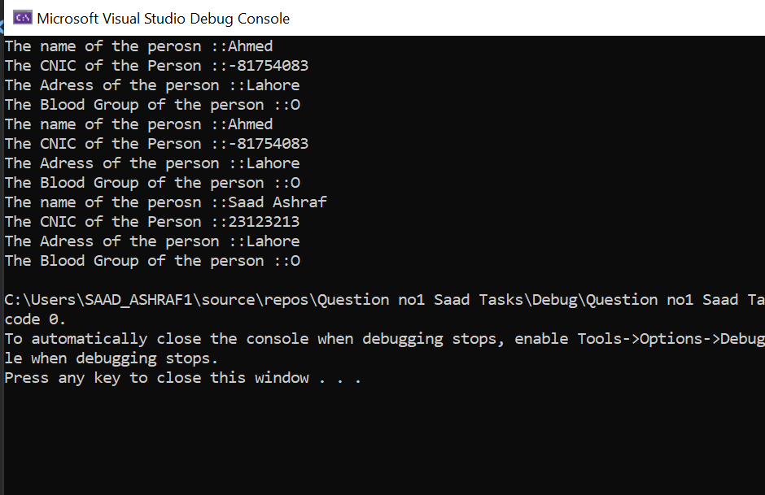

TASK 3:

#include<iostream>

using namespace std;

class LamberginiDablo {

string colour;

int cubiccapcity;

int numberoftheseats;

int numberoftheeats;

int yearofthemanufature;

int enginenumber;

int framenumber;

string *ownername;

public:

LamberginiDablo(string colour,int cubiccapcity,int numberoftheseats,int yearofthemanufature,int enginenumber,int framenumber, string ownername)

{

this->colour= colour;

this->cubiccapcity= cubiccapcity;

this->numberoftheseats= numberoftheseats;

this->numberoftheeats= yearofthemanufature;

this->yearofthemanufature= yearofthemanufature;

this->enginenumber= enginenumber;

this->framenumber= framenumber;

this->ownername = new string;

*(this->ownername) = ownername;

}

LamberginiDablo(LamberginiDablo const &a)

{

this->colour = a.colour;

this->cubiccapcity = a.cubiccapcity;

this->numberoftheseats = a.numberoftheseats;

this->numberoftheeats = a.yearofthemanufature;

this->yearofthemanufature = a.yearofthemanufature;

this->enginenumber = a.enginenumber;

this->framenumber = a.framenumber;

this->ownername = new string;

this->ownername = a.ownername;

}

void chage()

{

this->colour = "Green";

}

void Dispaly()

{

cout << endl;

cout<<this->colour;

cout << endl;

cout << this->cubiccapcity;

cout << endl;

cout << this->numberoftheseats;

cout << endl;

cout << this->numberoftheeats;

cout << endl;

cout << this->yearofthemanufature;

cout << endl;

cout << this->enginenumber;

cout << endl;

cout << this->framenumber;

cout << endl;

cout << *(this->ownername);

}

};

int main()

{

LamberginiDablo a("Red",123,2312,2312,213,123,"Ahmed");

LamberginiDablo *b = new LamberginiDablo(a);

b->Dispaly();

LamberginiDablo *c = new LamberginiDablo("Green", 123, 2312, 2312, 213, 123, "Ahmed");

*(c) = a;

b->Dispaly();

}

